Simulation instruction:

Visual Studio and PTV VISSIM are used.

1. Open and run “**DriverModel.vcxproj**” in Visual Studio, which is located at \source code\DriverModel_DLL_CAV to generate CAV control and CAV trajectory output DLL

The generated “**DriverModel.dll**” is located at \source code\DriverModel_DLL_CAV\x64\Debug

1. Open and run “**DriverModel.vcxproj**” in Visual Studio, which is located at \source code\DriverModel_DLL_HV to generate HV trajectory output DLL

The generated “**DriverModel.dll**” is located at \source code\DriverModel_DLL_HV\x64\Debug

1. Open “**I-75.inpx**” in PTV VISSIM
2. Right click on the AV row highlighted in red below and then click “Edit”

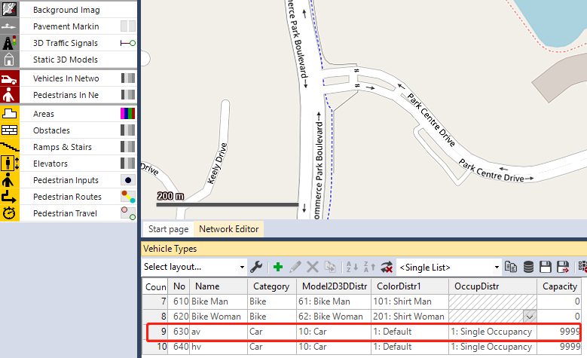

1. Click “External Driver Model” and locate the DLL generated in Step 1.

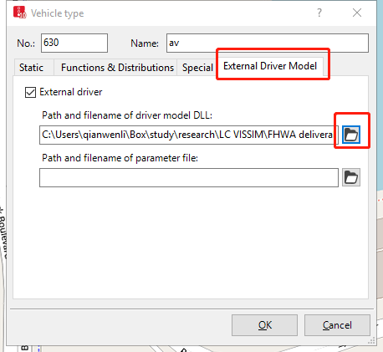

1. Right click on the HV row highlighted in red below and then click “Edit”

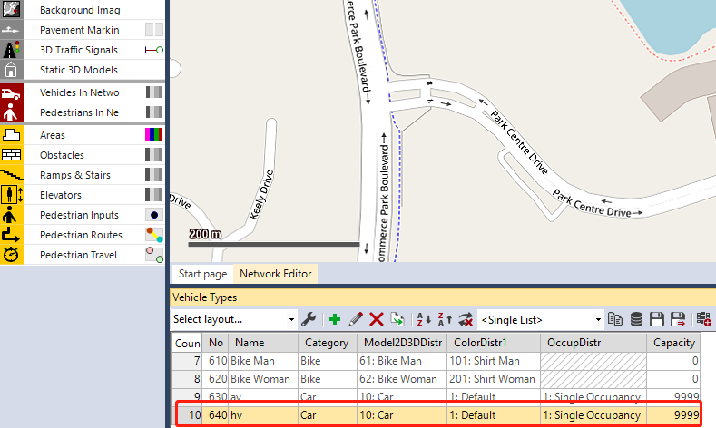

1. Click “External Driver Model” and locate the DLL generated in Step 2.

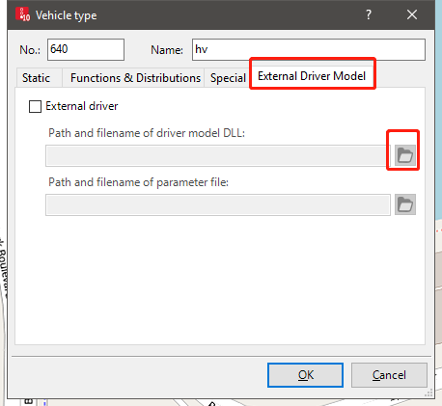

1. Run the simulation.